Name: _________________ PS ID # ___ COSC 3380

Exam 1
1. (20 points)

ERD – ANALYSIS - WHAT
Proper Textual Analysis is required (if not, you will get only half of the points!)
(Templates at the end of this EXAM)

Draw the ERD for keeping track of the exploits of your favorite sports team. You should store the matches played, the scores in each match, the players in each match, and individual player statistics for each match.
Player’s player_id, name, age, and season_score need to be stored in the database. Match’s match_id, date, stadium, opponent, own_score, and opp_score need to be stored in the database.

ANSWER:
Templates:
No TA - 10 pts
E1: Customer
No proper TA - 5 pts
R2: Place
(1 E1: Customer “Place” M E6: Orders)
E1: Customer – A1: C_ID

Not Copy & Paste - 5 pts
Not 2 Es, 1 R, 11 As - 4 pts
Not score on R - 4 pts
Copy, Paste, Rearrange ERD on this page.

2. (20 points)

ERD – ANALYSIS - WHAT
Proper Textual Analysis is required (if not, you will get only half of the points!)

Construct an ERD for a car insurance company whose customers own one or more cars each. Customer’s customer_id, name, and address need to be stored in the database. Each car has associated with it zero to any number of recorded accidents. Both car’s licence_no and model data need to be stored in the database. Accident’s report_id, date, and place need to be stored in the database. Each insurance policy (has a policy_id) covers one or more cars, and has one or more premium payments (amount) associated with it. Each payment (has a payment_no) and is for a particular period of time, and has an associated due date, and the date when the payment was received.

No TA - 10 pts
ANSWER:
Templates:
No proper TA - 5 pts

E1: Customer
R2: Place
(1 E1: Customer “Place” M E6: Orders)
E1: Customer – A1: C_ID

Not Copy & Paste - 5 pts
Not 5 Es, 4 Rs, 14 As - 4 pts
Not matching ERD - 4 pts
Copy, Paste, Rearrange ERD on this page.

ERD Model ANALYSIS - WHAT to Relational Model - DESIGN - HOW
3. (10 points)
(Must use ovals and Labels on the ERD for the Relations)

In this part you are to translate the ERD below to Relations. Use the Relational Model using SQL like statements that create the TABLEs including the foreign key and primary key indications!

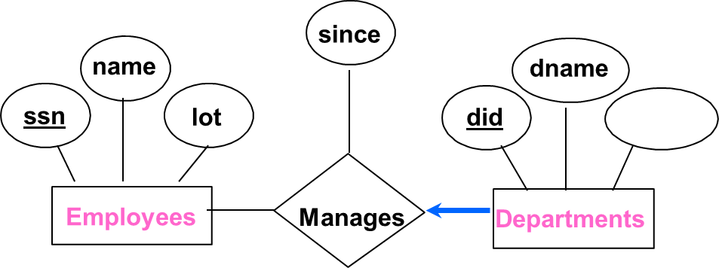
budget

Use the second approach presented in the textbook! (i.e., combine the E on the many side and the R into one Relation)

ANSWER:

No labeled ovals - 3 pts
Not 2 Relations - 2 pts
No PK & FK - 2 pts

ERD Model ANALYSIS - WHAT to Relational Model - DESIGN - HOW
4. (20 points)
(Must use ovals and Labels on the ERD for the Relations)

a. 1 (5 pts) Rewrite this ERD using the Lecture Notations
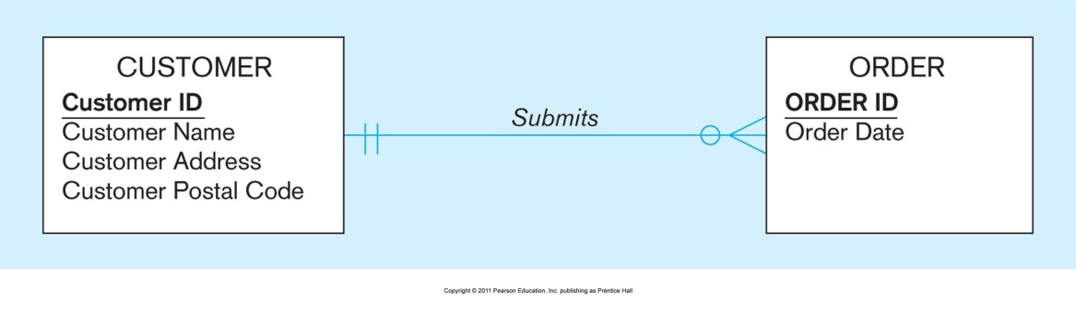
ANSWER:

Not correct - 2 pts

a. 2 (5 pts) Translate the ERD from a.1 to Relations.
Relational Model using TABLE format.
ANSWER:
Not recopied - 2 pts
Not labeled ovals - 2 pts

Not 2 Relations - 2 pts
No PK & FK - 2 pts
b. 1 (5 pts) Rewrite this ERD using the Lecture Notations
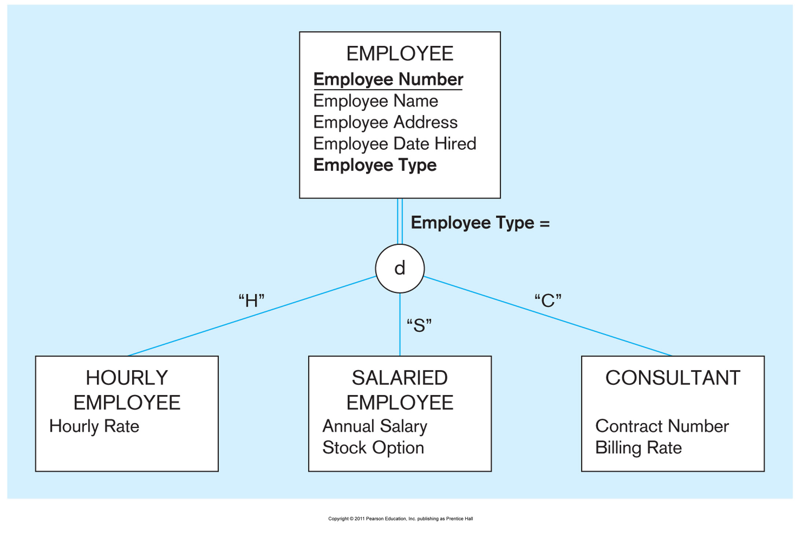
ANSWER:

Not correct - 2 pts

b. 2 (5 pts) Translate the ERD from b.1 to Relations.
Not recopied - 2 pts
Not labeled ovals - 2 pts
Relational Model using TABLE format.
ANSWER:
No PK & FK - 2 pts

Not 4 Relations - 2 pts

Normalization.
You must use the proper notations for attribute closure {B} = { , , , , }
5. (10 points)
You must use the proper notations for BCNF, 3NF, 2NF (draw the horizontal and vertical lines, use {X} notation, etc.)
+

Consider a relational schema R(A, B, C, D) with the following functional dependencies:

AB → C
No {...} ⁺ 4 Notation - 2 pts
ABD → C
ABC → D
AC → D

(a) (5 points) List all candidate key(s) of R.
You need to show all your work! As done in class.

ANSWER:
Not 1 Candidate Key - 2 pts

(b) (5 points) Is R in 3NF? WHY or WHY NOT?
You need to show all your work! As done in class.
ANSWER:
No proper justification - 2 pts

Normalization.
6. (20 points)
You must use the proper notations for attribute closure {B} = { , , , , }
You must use the proper notations for BCNF, 3NF, 2NF (draw the horizontal and vertical lines, use {X} notation, etc.)
+

(a) (10 points) Given relation R(A, B, C, D) and the set of FDs F={

AB C

BD A

D A

B C
}.

Is R in 3NF? WHY or WHY NOT?
You need to show all your work!

ANSWER:
No {...} ⁺ Notation - 2 pts

No proper justification - 2 pts

(b) (10 points) Given relation R(A, B, C, D) and the set of FDs F={

ABC D
BCD A

D C

ACD B
}.

Is R in BCNF? WHY or WHY NOT?
You need to show all your work!

ANSWER:

No {...} ⁺ Notation - 2 pts
No proper justification - 2 pts

